


WHEEL OPTION FITTING MANUAL
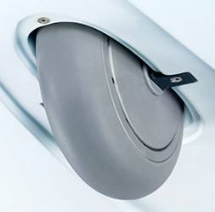

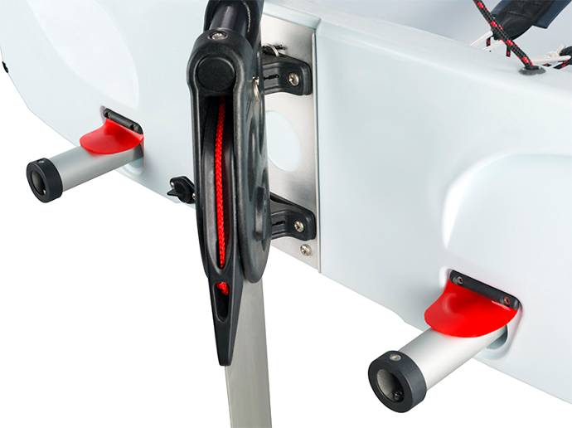

SAILMARKET, S.L.
NARCIS MONTURIOL 27
08339 VILASSAR DE DALT
BARCELONA - SPAIN

TEL 00 34 93 753 36 02
FAX 00 34 93 753 37 00
http://www.sailmarket.es
sailmarket@sailmarket.es

Contents

- Removing the Wheel Housing Blanking Plate
- Fitting the Wheel Assembly
- Fitting the Carry Handles

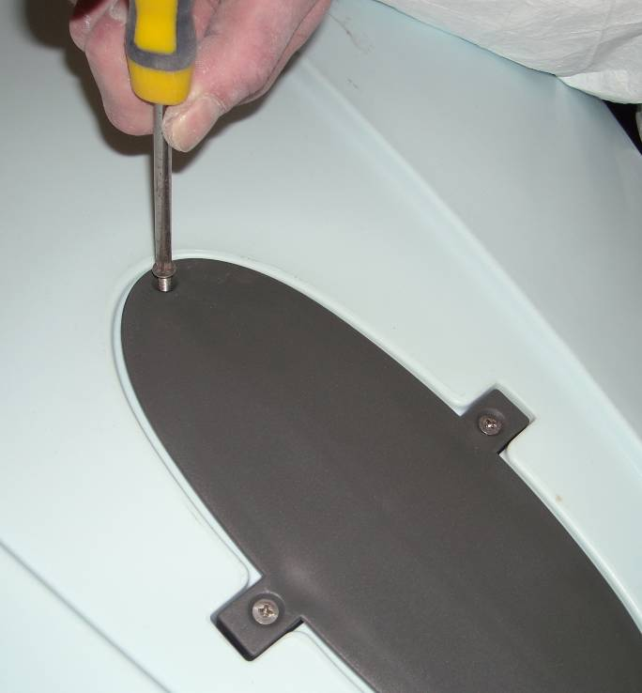

Removing the Wheel Housing Blanking Plate

Standard and race/performance specification Laser Bug’s are supplied with a wheel housing blanking plate fitted. This blanking plate must be removed to enable fitment of the wheel option:

  - Remove the posi drive self taping screws at the front and rear ends of the wheel housing.

  - Remove the posi drive machine screws at the left and right hand sides of the wheel housing.

  - The blanking plate can now be removed to expose the wheel housing cavity below.

Note: The wheel housing blanking plate is now surplus to requirement although the machine screws previously used to secure the left and right hand sides of the blanking plate will be reused during fitment of the Bug wheel assembly.

Fitting the Wheel Assembly

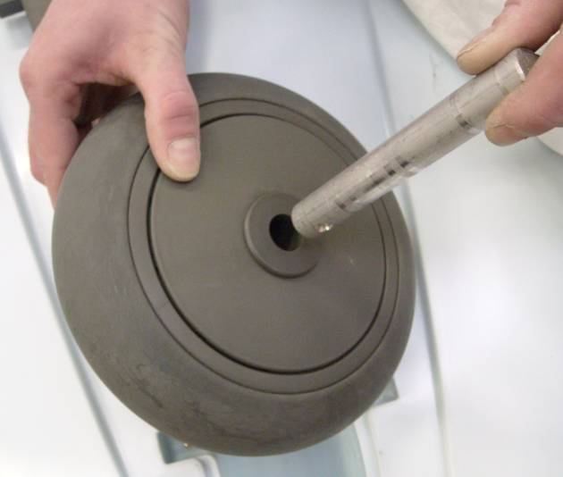

- Take the wheel and post the axle through its centre bush until an equidistant amount of axle protrudes from of each side of the wheel.

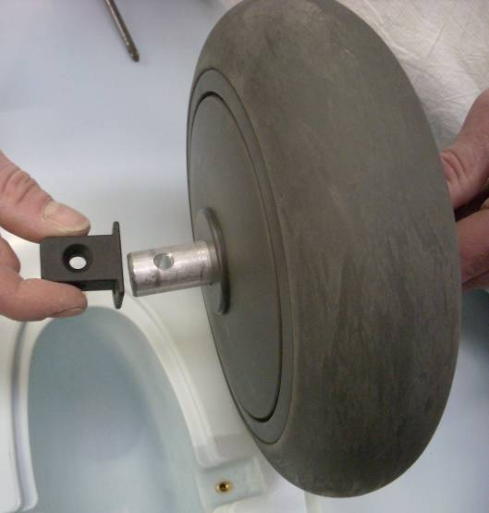

- Side an axle location bush on each end of the protruding axle until fitted flush with each side of the wheel.

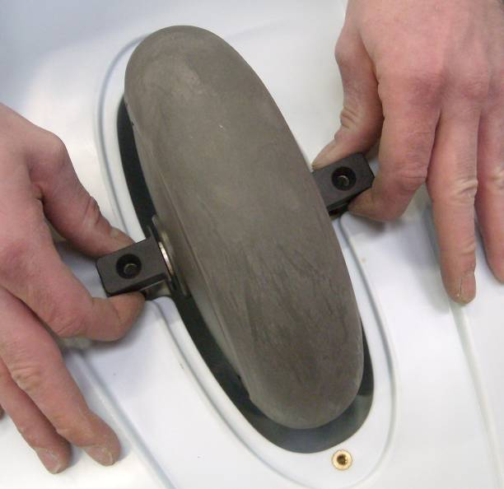

- Position the complete wheel assembly in to the wheel housing cavity.

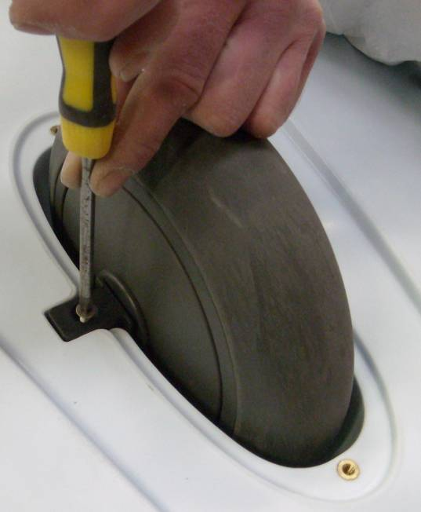

- Refit the machine screws that previously secured the left and right hand sides of the cover plate, this time securing the left and right hand sides of the wheel axle.

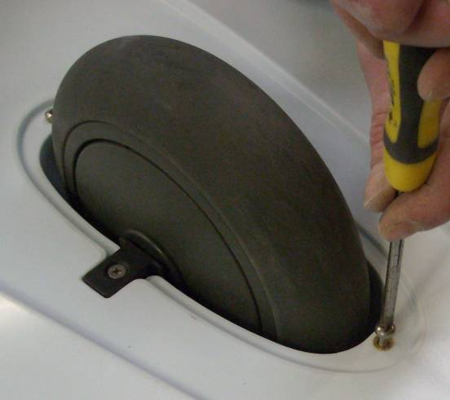

- Fit the pan head self tapers supplied with the wheel option fitting kit in to the remaining (now unutilised) holes in the front and rear ends of the wheel housing cavity.

Note: Care should be taken not to over tighten these self tapers as polyethylene is a soft material. (The holes in which could easily be stripped)

Fitting the Carry Handles

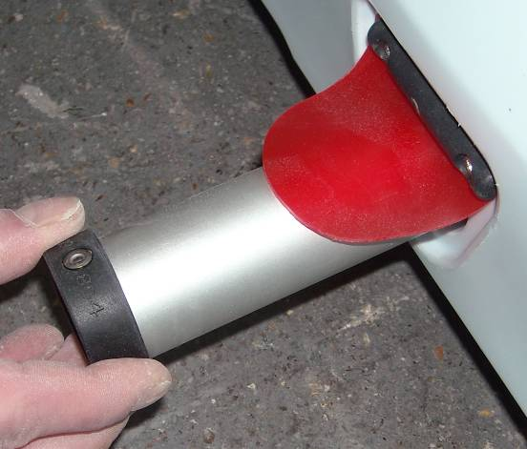

- Lift the transom flaps and insert the carry handles from the stern of the boat as shown.

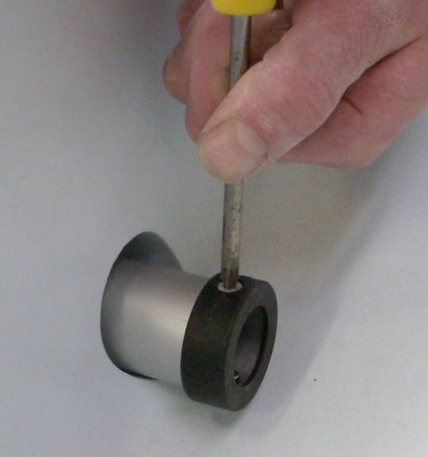

- Fit the retaining bushes on the forward/inboard ends of the carry handles using the short blunt self tapers and pre-drilled pilot holes supplied.

Your Bug Is Now Ready For Launching!
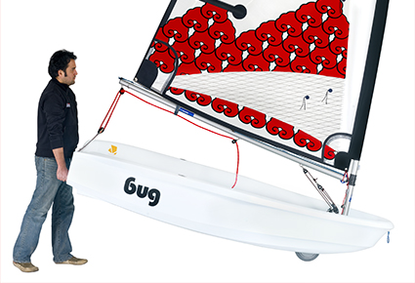

Enjoy Your Bug Sailing!

